Creating Console App for storing data in blobs

Step 1: Create New Console App from Visual Studio Template

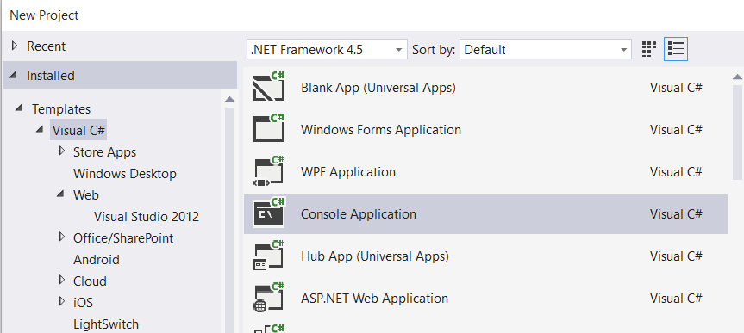

Step 2: Right click on Project name & select “Manage NuGet Packages…”

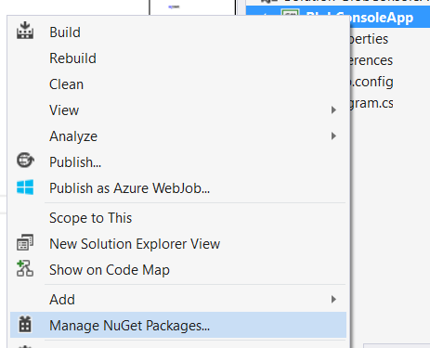

Step 3: Manage NuGet Packages dialog box will open & search for “Azure Storage”

Install “Windows Azure Storage”

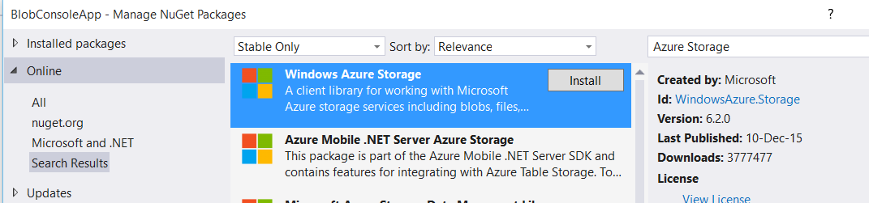

Step 4: Open app.config file, add an entry under the Configuration element, replacing the account name and key with your own storage account details:

<?xml version="1.0" encoding="utf-8" ?>

<configuration>

<startup>

<supportedRuntime version="v4.0" sku=".NETFramework,Version=v4.5" />

</startup>

<appSettings>

<add key="StorageConnectionString" value="DefaultEndpointsProtocol=https;AccountName=storageaccountname;AccountKey=storagekey" />

</appSettings>

</configuration>

Step 5: Add one reference

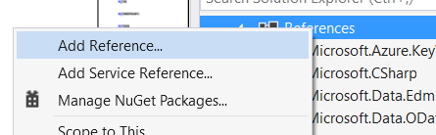

Select “System.Configuration”

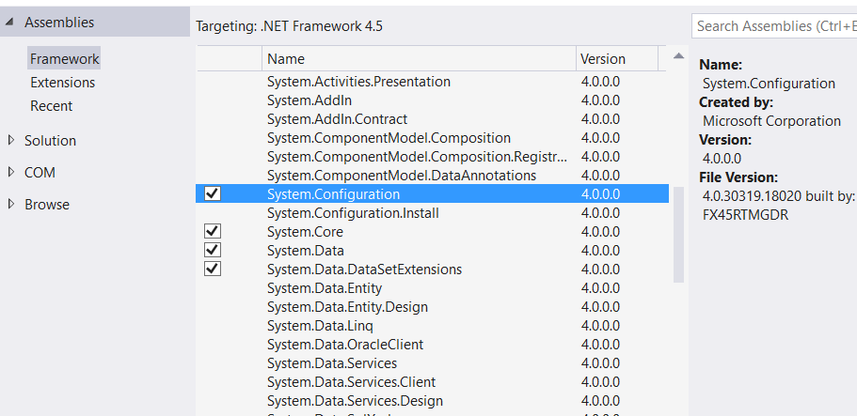

Step 6: Open Program.cs file

Add references of Azure Storage

using System.Configuration;

using Microsoft.WindowsAzure;

using Microsoft.WindowsAzure.Storage;

using Microsoft.WindowsAzure.Storage.Auth;

using Microsoft.WindowsAzure.Storage.Blob;

static void Main(string[] args)

{

//Retrieve Storage account from connection string

CloudStorageAccount storageAccount = CloudStorageAccount.Parse(ConfigurationManager.AppSettings["StorageConnectionString"]);

//Create the blob client

CloudBlobClient blobClient = storageAccount.CreateCloudBlobClient();

//Retrieve a reference to a container

CloudBlobContainer container = blobClient.GetContainerReference("storagecontainer");

//Create the container if it doesn't already exist

container.CreateIfNotExists();

//Retrieve reference to a blob named "storageblob"

CloudBlockBlob blockBlob = container.GetBlockBlobReference("BlobFile.txt");

//Create or overwrite the "storageblob" blob with contents from a local file

using (var filestream = System.IO.File.OpenRead(@"C:\azure\BlobFile.txt"))

{

blockBlob.UploadFromStream(filestream);

}

}

